UX Testing:
User Experience testing is about ensuring that an application is easy to use, accessible, and provides a seamless experience for users. It goes beyond functional testing to check how real users interact with the product.
Type of UX testing:
Usability Testing:
o Checking how easy it is to use the app
o Simplicity, clarity, and efficiency of the interface.
o Ex: Testing if users can “find the "Checkout" button easily” in an e-commerce app.
Accessibility Testing:
o Ensuring the app is usable for people with disabilities
o Screen readers, keyboard navigation, color contrast.
o Ex: Checking if a visually impaired user can “navigate using a screen reader”.
Performance UX Testing:
o Checking load speed and UI responsiveness
o Load time, UI delays, responsiveness across devices.
o a page loads within 3-4 seconds
A/B Testing:
o Comparing two versions of a UI.
o Button placement, color, CTA (Call-to-Action) effectiveness.
o Testing "Buy Now" vs "Add to Cart" button to see which gets more clicks.
·Heatmap Testing:
o Analyzing where users click and scroll
o Identifying “hot spots” and “ignored areas” on a webpage.
o click an unclickable element.
Cognitive Walkthrough Testing:
o Navigation flow, ease of use, logical steps.
o New user can sign up without confusion.
o Simulating a first-time user's experience
Eye-Tracking Testing:
o Seeing what elements grab user attention
o Finding the most “attention-grabbing elements”.
o Analyzing if a “pop-up disrupts the natural reading flow”.
Error Handling & Feedback Testing:
o Ensuring clear and helpful error messages.
o Clarity and helpfulness of feedback.
o Instead of saying "Invalid input", the app should say "Please enter a valid email address"
Survey & Feedback-Based Testing:
o Gather user feedback about their experience.
o Identifying common pain points and areas for improvement.
o Asking users: “What frustrated you most about this app?”
Burp Suite:
Burp Suite is a web security testing tool used to find vulnerabilities in web applications. You can use it to test how secure a web app is and identify issues like weak authentication, broken sessions, and security misconfigurations.
There are three editions of Burp Suite:
- Community Edition (Free, limited features).
- Professional Edition (Paid, advanced scanning tools).
- Enterprise Edition (Automated scanning for large-scale applications).
Basic Tools in Burp Suite:
- Proxy: Intercepts and modifies HTTPs requests and responses, allowing testers to analyze how data is transmitted between the client and server.
- Target: Provides a structured view of the application's endpoints, helping testers understand its structure and potential weak points.
- Intruder: Automates sending multiple requests with different inputs to test for vulnerabilities like SQL injection and XSS.
- Repeater: Manually modifies and resends requests to check how the server responds, useful for debugging and testing security flaws.
- Decoder: Converts encoded data (like Base64 or URL encoding) into a readable format, making it easier to analyze data manipulation.
- Comparer: Compares different responses or requests to identify changes, useful for regression testing and security assessments.
- Sequencer: Analyzes the randomness of session tokens or authentication keys to detect weak implementations.
- Extender: Allows adding plugins and custom scripts to enhance Burp Suite’s capabilities.
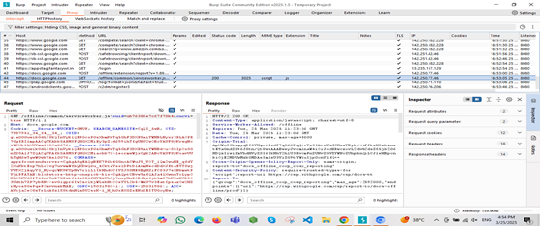

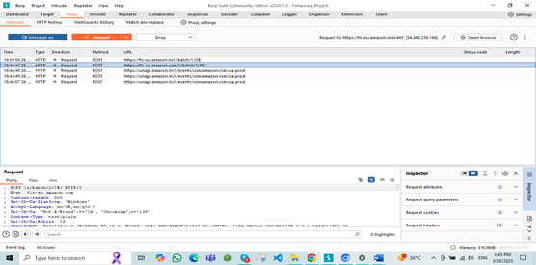
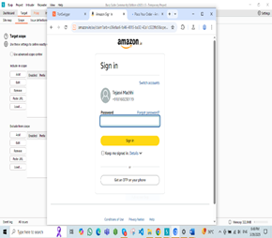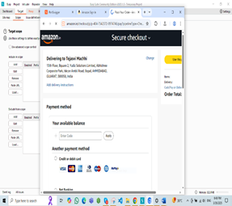
Payloads: The Intruder tool in Burp Suite is used to automate attacks with different payloads.
Payloads common password lists:
( https://drive.google.com/drive/folders/1u11UgooJ3pRt-3gSK7Z5t6bgJH7r8QZI?usp=drive_link )
Payloads in Intruder:
- Capture a Request
- Configure Target
- Set Attack Positions
- Load Payloads
- Start the Attack
Payloads in Repeater:
- Capture a request in Proxy.
- Send it to Repeater (Right click ----> Send to Repeater).
- Modify parameters in Repeater with your payloads.
- Click Send and analyze the response
Extensions for Payloads:
- Install extensions from BApp Store (e.g., Turbo Intruder for advanced attacks).
- Use Payload Processing (in Intruder) to modify payloads dynamically).
Types of Payloads:
- SQL Injection: ' OR '1'='1' --
- XSS: <script>alert(1)</script>
- Command Injection: ; ls -la
- Brute Force: Password lists (rockyou.txt, etc.)

